|  |  |
| --- | --- |
| **Ex.No:07b** | Configuration of Address Resolution protocol |
| **Date :** |

**Objective(s):**

To design and implement Address Resolution Protocol using packet tracer

**Introduction:**

ARP (Address Resolution Protocol) is a network protocol used to find out the hardware (MAC) address of a device from an IP address. It is used when a device wants to communicate with some other device on a local network (for example on an Ethernet network that requires physical addresses to be known before sending packets). The sending device uses ARP to translate IP addresses to MAC addresses. The device sends an ARP request message containing the IP address of the receiving device. All devices on a local network segment see the message, but only the device that has that IP address responds with the ARP reply message containing its MAC address. The sending device now has enough information to send the packet to the receiving device.

1. **Device Requirements:**

1.

2.

3.

4.

1. **Network Diagram for your experiment (draw the diagram either hand drawing/ms paint or any other drawing tools)**

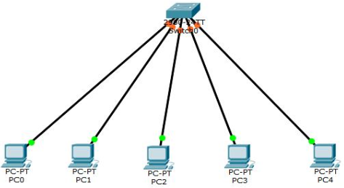

1. **Network Diagram (Packet tracer diagram before configuration):**
2. **Configuration details:**

|  |  |  |  |
| --- | --- | --- | --- |
| **Device Name** | **Interface Name** | **IP Address** | **Subnet mask** |
|  |  |  |  |
|  |  |  |  |
|  |  |  |  |
|  |  |  |  |
|  |  |  |  |
|  |  |  |  |

1. **Describe step by step configuration steps properly (you may copy the commands used in the configuration tab and paste it.)**
2. **Output Diagram (Minimum 3 screenshot):**

**Google Drive link of the packet tracer file (give view permission):**

**Link:**

**CONCLUSION (provide conclusion about this experiment):**

**Rubrics for Experiment Assessment:**

|  |  |  |  |  |
| --- | --- | --- | --- | --- |
| **Rubrics** | **Good** | **Normal** | **Poor** | **Marks** |
| **Creation of Topology (4)** | Created the topology, Identify the proper devices and making the connections **(4)** | Created the topology, Identify the proper devices, making the connections But missing some features **(3)** | Created wrong topology, Failed to Identify the proper devices and making connections **(1)** |  |
| **Verify the connectivity (4)** | Verified the connectivity in all the levels **(4)** | Verified the connectivity at some levels (only some nodes) **(2)** | Verified the connectivity is not done. **(1)** |  |
| **Timely Completion (2)** | Completed the lab before the allotted time **(2)** | Completed the lab after the deadline **(1)** | Did not submitted before grading **(0)** |  |
| **Tota**l | | | |  |